
Author Visit
We are delighted to announce that author Matt Beighton will be visiting us on [[DATE]] to run creative writing sessions with our children.
As part of the visit, Matt will have signed copies of his book for sale. Pre-orders can be made via https://www.mattbeighton.co.uk/shop. Please make sure to add your child’s name and class when you add the books to your basket. Matt will also have books available to buy on the day.

Please note that Matt cannot accept the £1 World Book Day tokens.

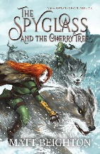 | The Spyglass and the Cherry Tree (Recommended age 9+) - £10  Narnia meets Middle Earth: Skye Thistle has no option but to join forces with the Goblin army and learn how to fight for her life in this first entry in a fast-paced and dazzling epic fantasy series – an exciting tale that merges magic, adventure, a rising darkness and a search for strength and acceptance.  “The Spyglass and the Cherry Tree is a brilliant fantasy adventure with a journey about confronting fears and trials to become a hero, with a variety of eccentric characters, an evil queen, and the quest for a magical stone.” – ReadersFavourite.com
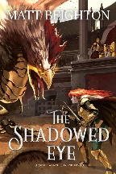 | The Shadowed Eye – The Sequel to spyglass and the cherry tree (Recommended age 9+) - £10  The war isn't over  Do not make the same mistakes I did...  Those were the words her mother had left when Skye Thistle returned home to Earth from her adventures on the distant world of Ithilmir. If only it were that simple.  Once again, she is called upon to fight. This time, she’s not alone.
 | The Monstacademy and Pick your Path Adventure books have all been designed with dyslexia accessIbility in mind
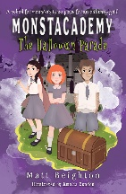 | The Halloween Parade – Monstacademy #1 (Recommended age 7+) - £8  Joining a new school is hard enough; it’s even harder when your new school is full of monsters.  On her first day at Monstacademy, Trixie Grimble soon realises that she’s going to have to adjust to her new classmates quickly. It doesn’t help that she’s been given an incredibly important job for the upcoming Halloween Parade and that her only friends are a cursed werewolf and a vegetarian vampire.  Fans of Jill Murphy’s The Worst Witch and Hotel Transylvania will adore the silly humour and lovable characters in this delightful modern classic chapter book series.  Includes the short story "The Christmas Cat Circus".
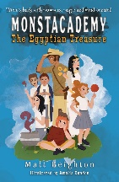 | The Egyptian Treasure – Monstacademy #2 (Recommended age 7+) - £8  Trixie’s back, and this time she’s got Mummy trouble!  When the Ankhstone is stolen, everyone is a suspect, and it’s up to Trixie, Gloria and Colin to find out who the true culprit is before the terrible mind-control powers of the ancient curse are unleashed on Monstacademy.  Can Gloria overcome her crush in time to help Trixie and Colin wrap up the case?
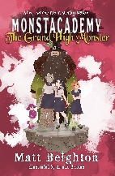 | The Grand High Monster – Monstacademy #3 (Recommended age 7+) - £8  There’s a traitor at Monstacademy!  When Trixie returns to Monstacademy after being suspended, her best friend Gloria doesn’t seem herself. To make matters worse, she’s suddenly best friends with an exciting new monster. Is the new girl all that she seems, or are the Mean Ghouls up to no good?  Will a surprise visit from the Grand High Monster spell the end for Monstacademy?
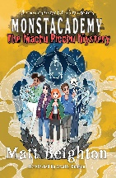 | The MACHU PICCHU MYSTERY – Monstacademy #4 (Recommended age 7+) - £8  The mountains are full of secrets...  Trixie, Gloria and Colin are off on a trip to Peru to study ancient monsters. When they arrive and find that the children of the local school for monsters are disappearing, it becomes a race against time. Has a dark secret that's been trapped in the mountains come back to haunt them all? Has an ancient Inca curse been released? Or is it somebody much closer to home?  The Machu Picchu Mystery is released on October 30th, but order here to get a copy before anybody else!
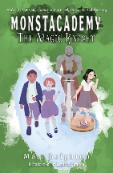 | The Magic Knight – A monstacademy Choose-your-own-path adventure (Recommended age 7+) - £8  A magical suit of armour has gone missing in suspicious circumstances, and there’s only one person who can help to solve the mystery. You!  With nearly 20 different endings, freezing spells and plenty of other silly twists and turns, The Magic Knight is a fantastic adventure that puts you in control of the action. You choose the story by making decisions and following your instincts. But be warned, not all endings are happy!
The pick your path adventure books are interactive gamebooks. You read a short section and then decide where you want to go next in the story. readers use dice to fight monsters as they go.
For more information, visit www.pickyourpathadventures.com
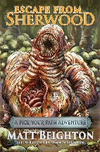 | Escape from sherwood – Pick Your Path adventure gamebook #1 (Recommended Age 8+) - £10  Set amidst the tangled roots and twisted trees of Sherwood Forest, an epic adventure awaits you in Escape From Sherwood. Only you control your fate as you step into the shoes of the hero and roll the dice of destiny…  Escape From Sherwood is the first in the Pick Your Path Adventures series, where you, the reader, take control of the story. You decide which paths to take, when to fight and when to flee. Take notes of everything you see, but always remember to choose carefully…
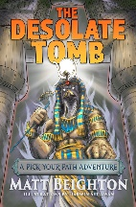 | The desolate tomb – Pick Your Path adventure gamebook #2 (Recommended Age 8+) - £10  The hot desert sand seems far away as you step into the gloomy darkness beneath an Ancient Egyptian tomb. Ahead of you lie tunnels and traps that haven’t been seen by living eyes for thousands of years. Your fate is in your hands as you, the reader, take on the role of a tomb raider and step beyond the mortal realm.  Whether you return with the Golden Heart or die a miserable death alone in the darkness is down to you, the reader, as you take control of the action in the second Pick Your Path adventure. Roll the dice of destiny and hope that your chosen path is littered with nothing more than the bones of previous adventurers. Whatever you do, choose carefully…
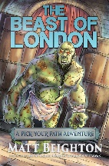 | Beast of london – Pick Your Path adventure gamebook #3 (Recommended Age 8+) - £10  Penny dreadfuls are all the rage, but the monsters aren’t just on the page. They are alive and wandering the streets, and Victorian London is at risk. Zombies, werewolves and many more are threatening to rip apart society, but there’s one beast in particular that has caught your attention.  Your journey through Victorian London will be fraught with the foulest monsters imaginable. You, the reader, must take control of the story in the third Pick Your Path adventure and earn a reputation as the greatest monster hunter of all time.
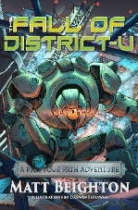 | the fall of district-u – Pick Your Path adventure gamebook #4 (Recommended Age 9+) - £10  In the distant future, the universe is a barren place. Mining factories known as districts have sprouted on every planet as a way to harvest a universal energy source called flux. Society is broken, and law and order are nonexistent. Only the word of the emperor, an elusive and distant entity, carries any force. The rest of the time, it is left to the clans that roam the slums and shantytowns to administer what counts as justice.  Journeying through the ceaseless rain and pulsing neon lights won’t be easy. The streets are filled with traitors and clans who play by their own rules. You, the reader, must take control of the story in the fourth Pick Your Path adventure and bring an end to the tyranny in District-U.
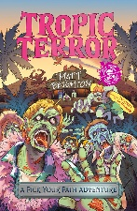 | Tropic Terror – Pick Your Path adventure gamebook #3 (Recommended Age 9+) - £10  Business retreats to tropical islands are normally boring affairs, stuffed with lectures and sleazy salesmen. Very rarely are they a matter of life and death, but your visit to Ghost Island quickly descends into madness.  Keeping yourself alive whilst figuring out a way to summon help isn't going to be easy. It's not just the hordes of zombies that you need to worry about; even the animals have vendettas. As the reader, this is your adventure, and it's your survival on the line in the fifth pick your path adventure.  Look behind you. The zombies are coming...

